Lab sheet - 02 CIS 31041 - Practical for Data Mining
Reg No:SEU-IS-19-ICT-003
Topic: Introduction to Weka.
Aim:
Understating Weka interface.
Understanding source file format.
Understanding data type.
Task:
- Download and Install Weka software ( https://waikato.github.io/wekawiki/downloading_weka/).
- Practices with Weka interface.
- Work with data Explorer.
- Import the labor.arff data set from data folder.
- Work with labor.arff data set .
- Mostly use data types.
- Work with data preprocessing.
- Visualize the attribute .
- Introduction to Class attribute.
- Visualize the whole attribute.
- Visualize the attribute in the Weka explorer panel.
- Explain the visualised attribute.
- Edit the data set.
- Remove any attribute.
- Save the changed source file.
Exercise

- Import the data segment _test.arff in the Weka data folder.
- Visualize all the attribute in the data set and interpret the result.
- Set the class attribute as Class and draw the scatter plot of the whole attribute and explain the relation with the class attribute and regional-centroid attribute.
- Remove the attribute regional-pixel-count, short-line-density-2, short-line- density-5 in the source file and save the source file.

Task:
- Download and Install Weka software

Open the web browser Navigate the weka download web page using this link https://waikato.github.io/wekawiki/downloading_weka download the weka software Double click on the weka software and do the installation setup like normal software

- Practices with Weka interface.
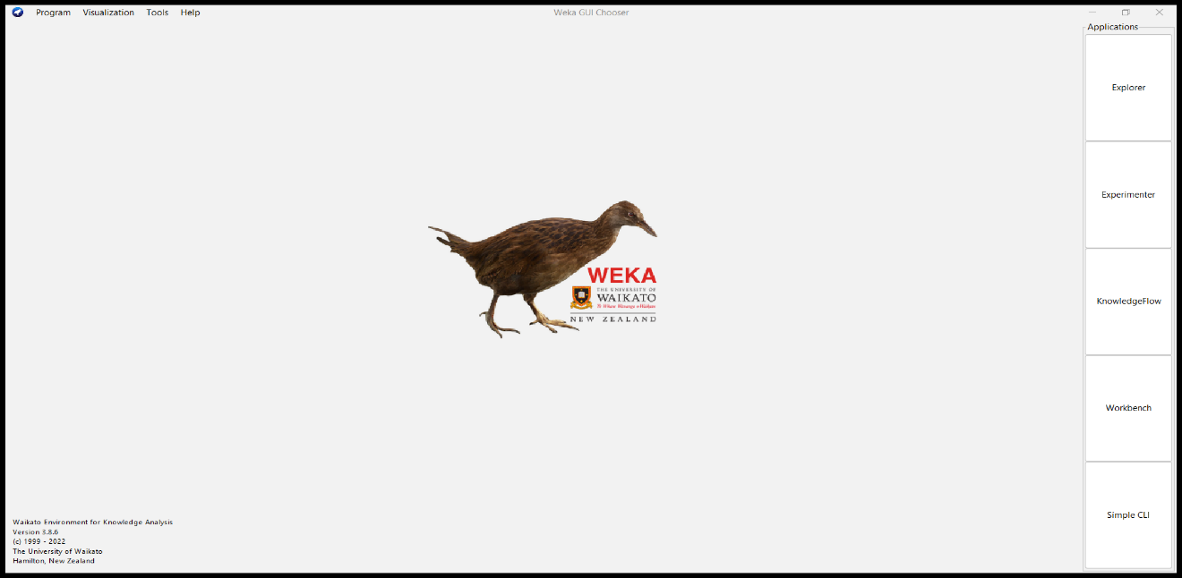

- Explorer: The main interface used for the majority of data mining operations. This panel will be discussed in more detail in later parts.
- Experimenter: We can plan and conduct experiments using this panel.
- Knowledge Flow: It offers an interface for connecting and dragging elements to create a knowledge flow, as well as for analyzing data and outcomes.
- Workbench: a well-curated set of cutting-edge data preprocessing tools and machine learning techniques. Using these methods primarily involves calling them from the command line.
- Simple CLI: The panel gives you the command line capabilities to operate WEKA. For instance, we'll use the command line to launch the ZeroR classifier on the Arff data

- Work with data Explorer.

Open the weka software in the main interface there is an option called Explore Click on it
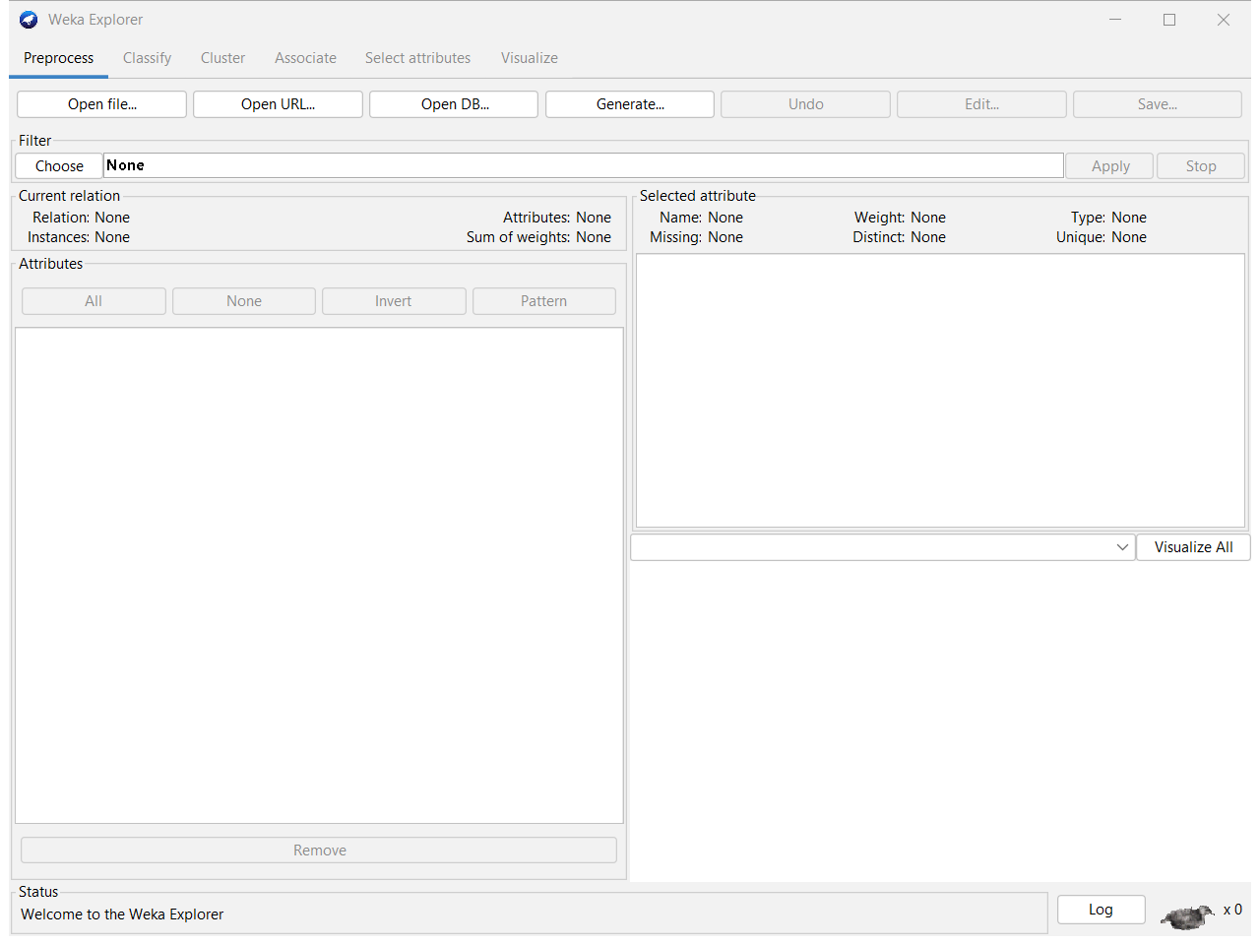

Data Explore let us to lord the data in different ways
- Using local file System.
- Using public web address.
- Using query to database.
- Generate artificial data to run models.

- Import the labor.arff data set from data folder.
- First make sure you are in a weka explorer pane
- Then after in that pane there is a option called “Open File” click on it
- Select the location where the labora.arff file available
- Click on “open”

- Work with labor.arff data set
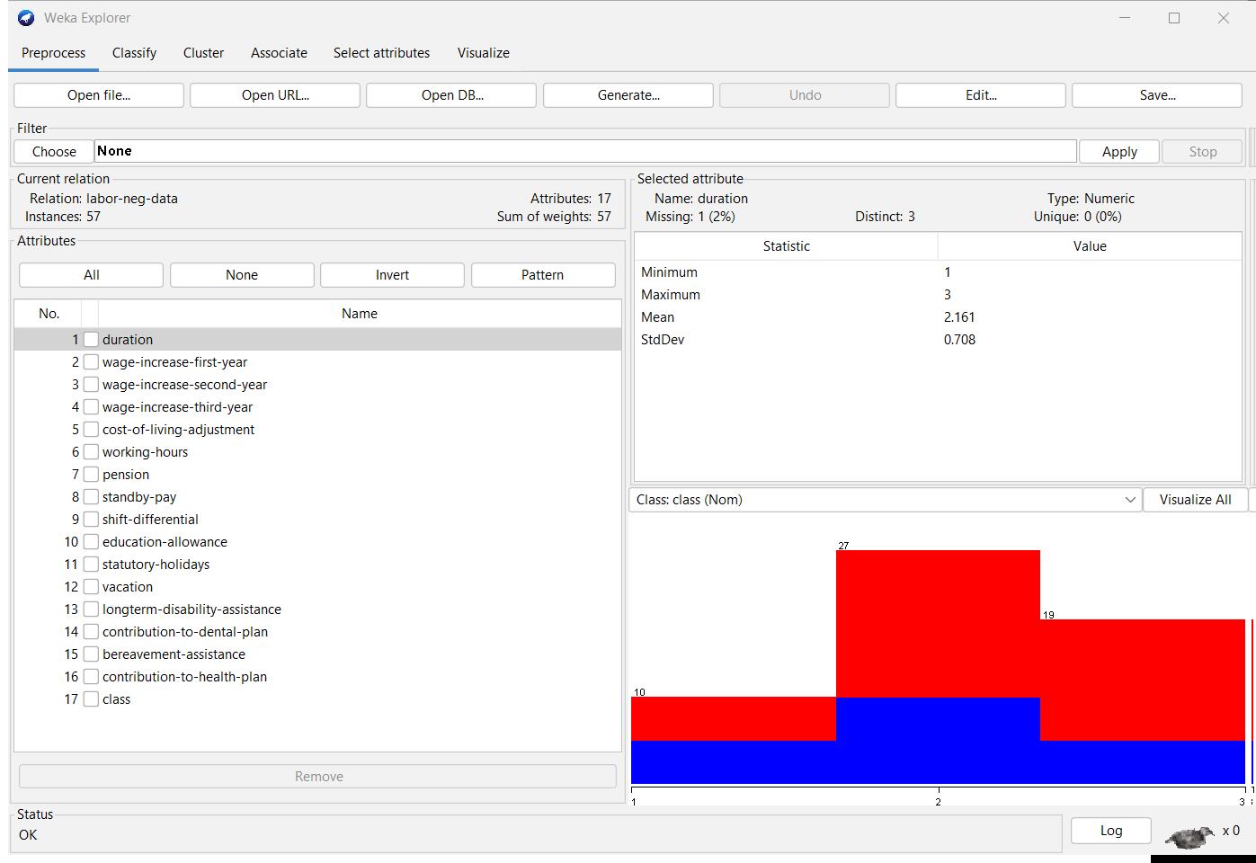
.

- In the left-top we can explore the relation’s name of the data set, number of attributes, number of instance and sum of weight
- In the right-top we can explore the name of the selected attributes, its data type, missing, distinct and unique values
- In the left bottom we can explore the attributes
- In the right bottom we can explore the visualization of each attributes

- Mostly use data types.
- String
- Data
- Integer treated as numeric
- Real treated as numeric
- date
- Relational for multi instance data
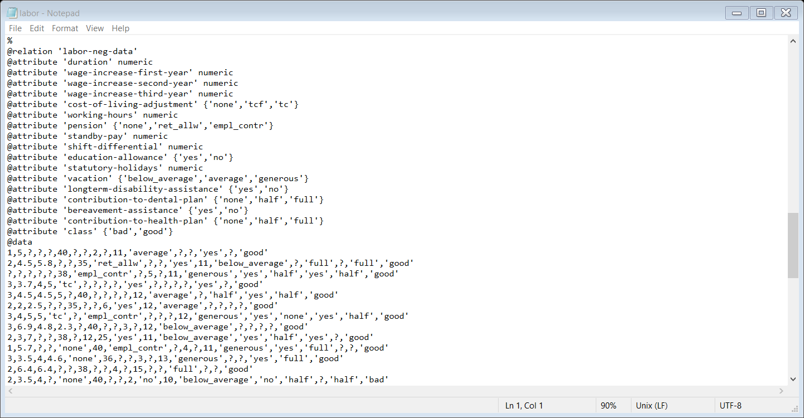
Example

- Work with data preprocessing.
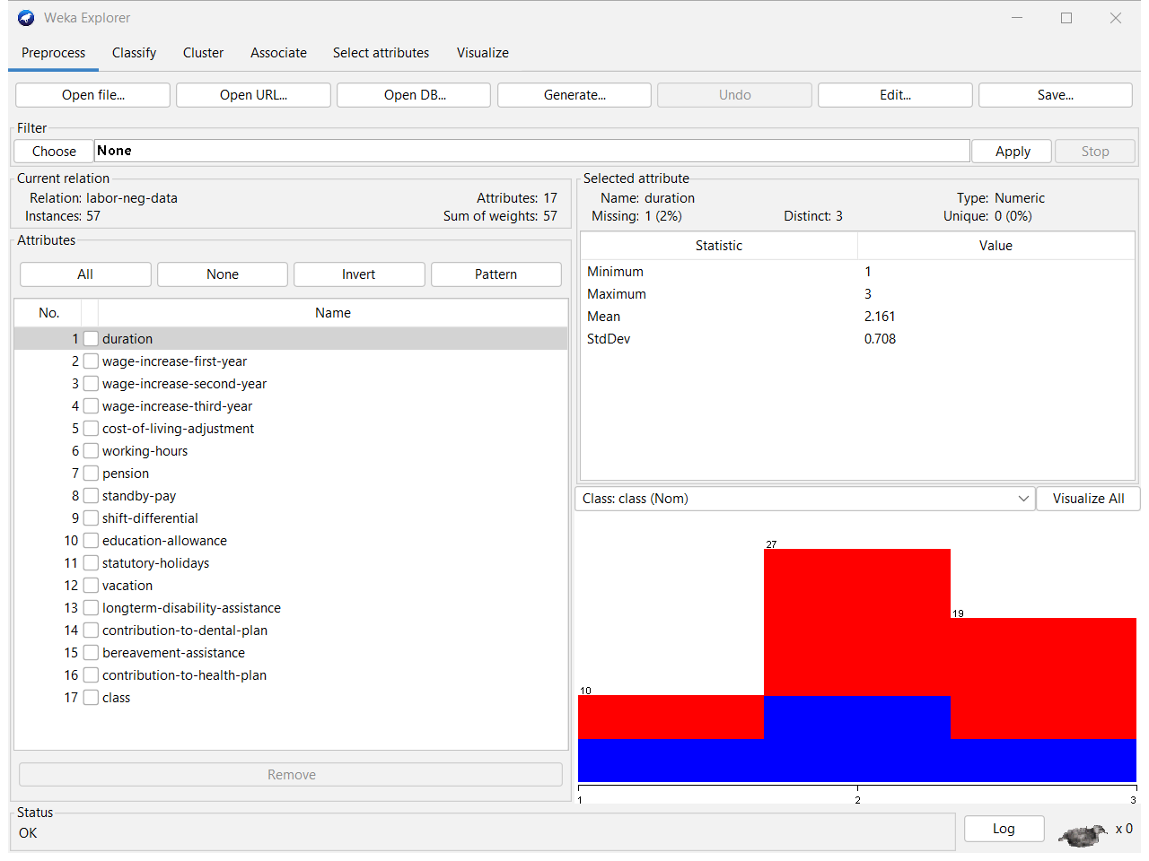

- Visualize the attribute
- In the attributes list there are 17 attributes selecting the relevant attribute you can visualized that attribute
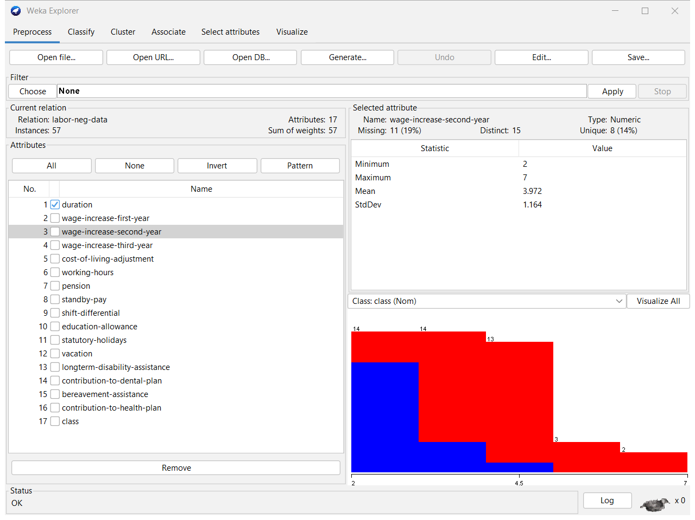

- Introduction to Class attribute.
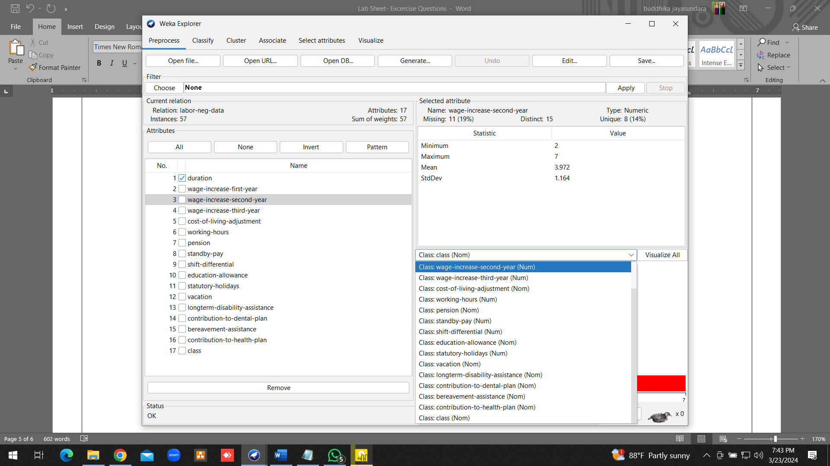

- According to our choice. We can change the class attribute through the drop-down menu which I highlighted

- Visualize the whole attribute.

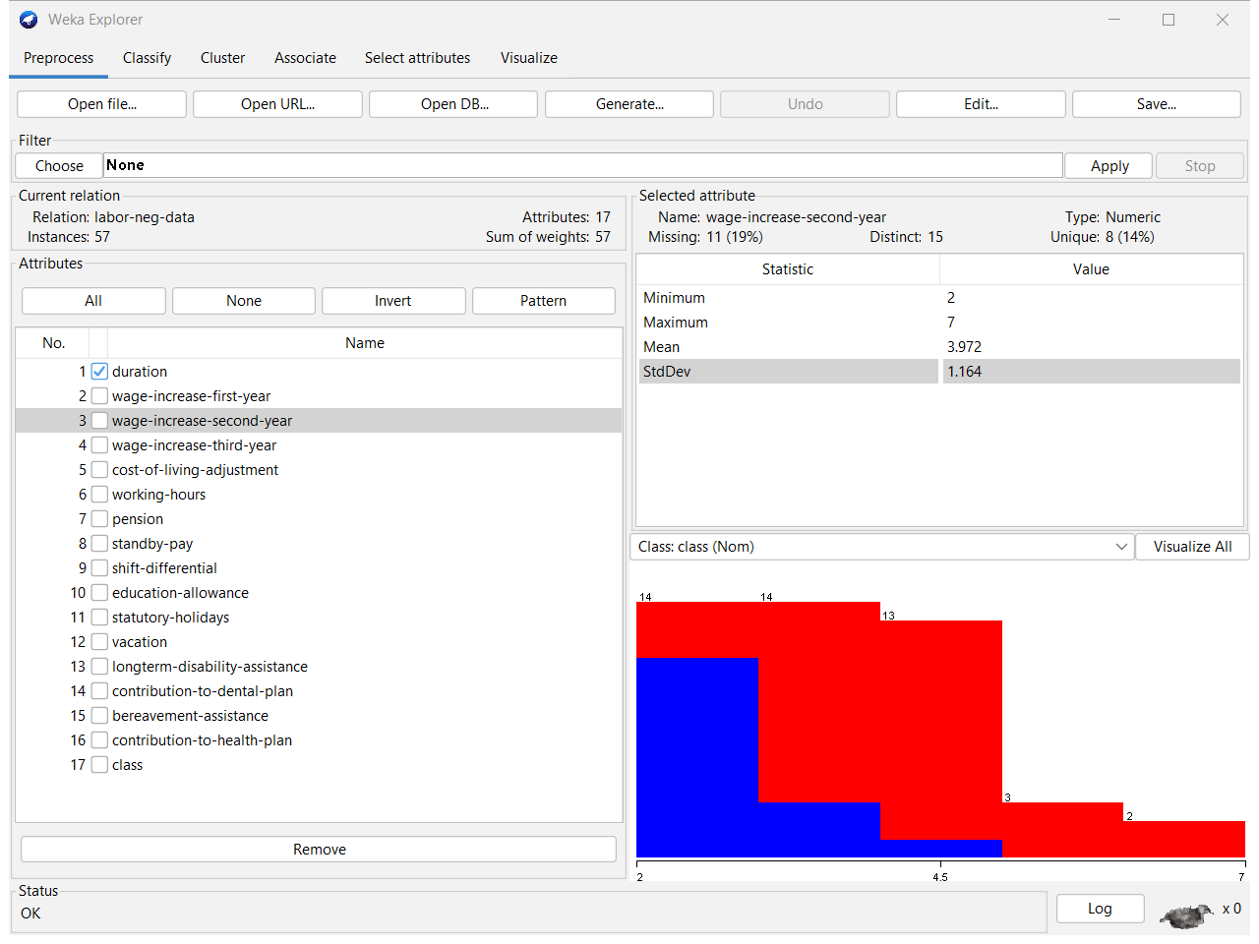

- By click on the Visualized all button in In the weka explore you can obtain visualization of all attributes pane

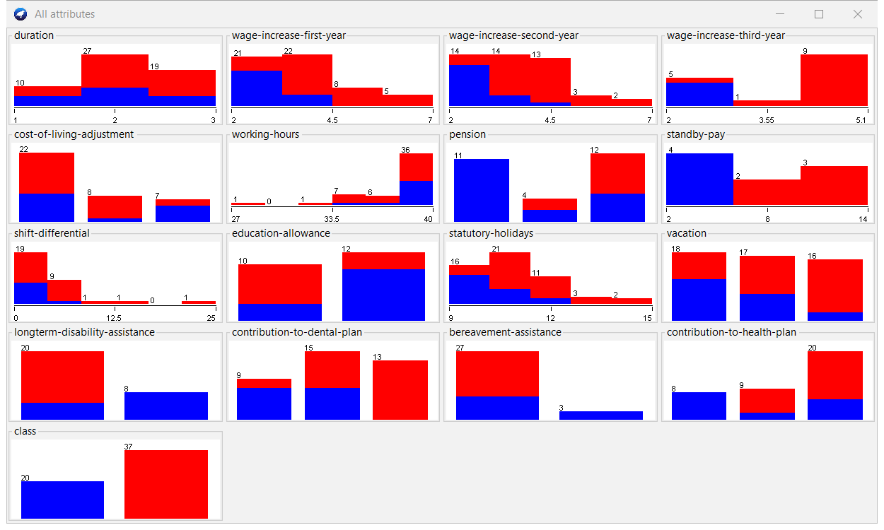

- Visualize the attribute in the Weka explorer panel.
- Go to the weka explore pane
- there is a tab name called visualize
- Click on it then Visualize attribute will appear

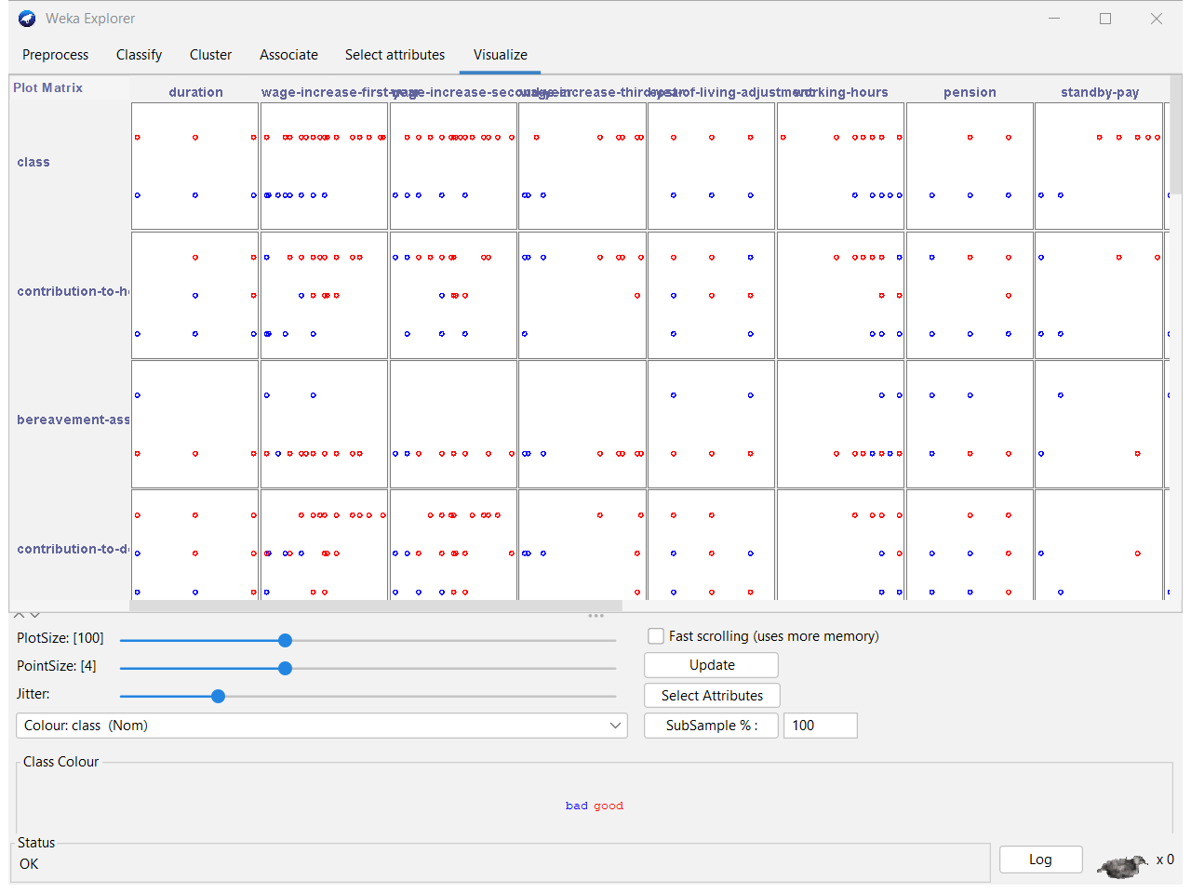

- Explain the visualised attribute.

- When a feature or attribute of a dataset is shown graphically for study and visualization, this is called the "visualized attribute." It helps people figure out how the data is spread out, what trends it shows, and how it all fits together.

- Edit the data set.
- Make sure you are in a weka explore pane
- Within that Click preprocessor tab
- Top right side there is a option name called edit click on it
- Then viewer pane will appear
- Within that you can edit attributes values and add values for missing attributes as well
- After changes click on “ok” to save changes

- Remove any attribute.
- Click on Choose button under the Filter.
- Filters Unsupervised Attribute Remove Double-click on Remove Enter the number of the attribute you want to remove Press OK
- The attribute will be removed.

- Save the changed source file
- Click on Save button.
- Navigate the location you want to save.
- Enter the file name with the extension name called (“.arff”).
- Finally Click on Save.

Exercise

- Import the data segment_test.arff in the Weka data folder.

- Open Weka Explorer pane .
- Click on the “Open File”.
- In the Open dialog box go to the location
- choose the file segment_test.arff file.
- Click on “open”

- Visualize all the attribute in the data set and interpret the result.
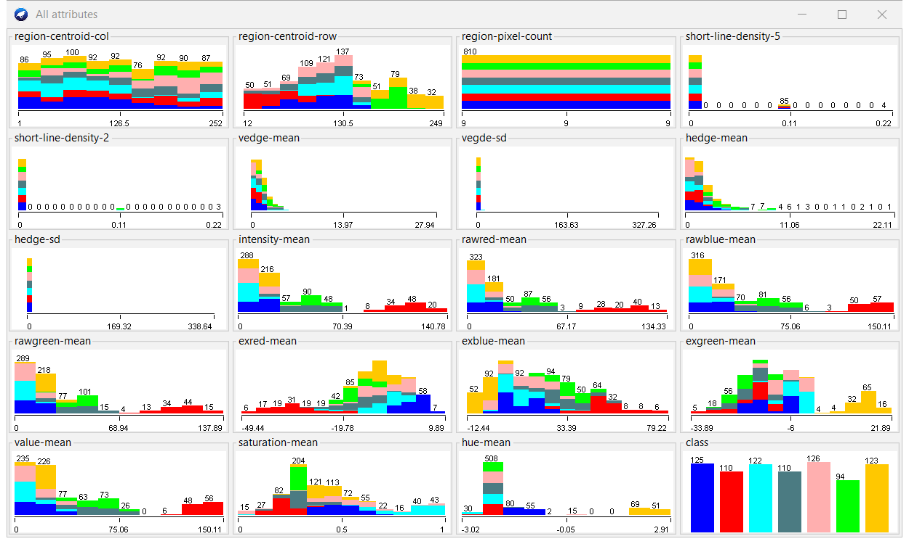

- Set the class attribute as Class and draw the scatter plot of the whole attribute and explain the relation with the class attribute and regional-centroid attribute.

- The class attribute tells you what variable you want to predict, and the regional-centroid attribute usually tells you where the data's center points are. The connection is based on how the regional centers may affect or be linked to the class results, which can help with sorting tasks or figuring out patterns in the data.

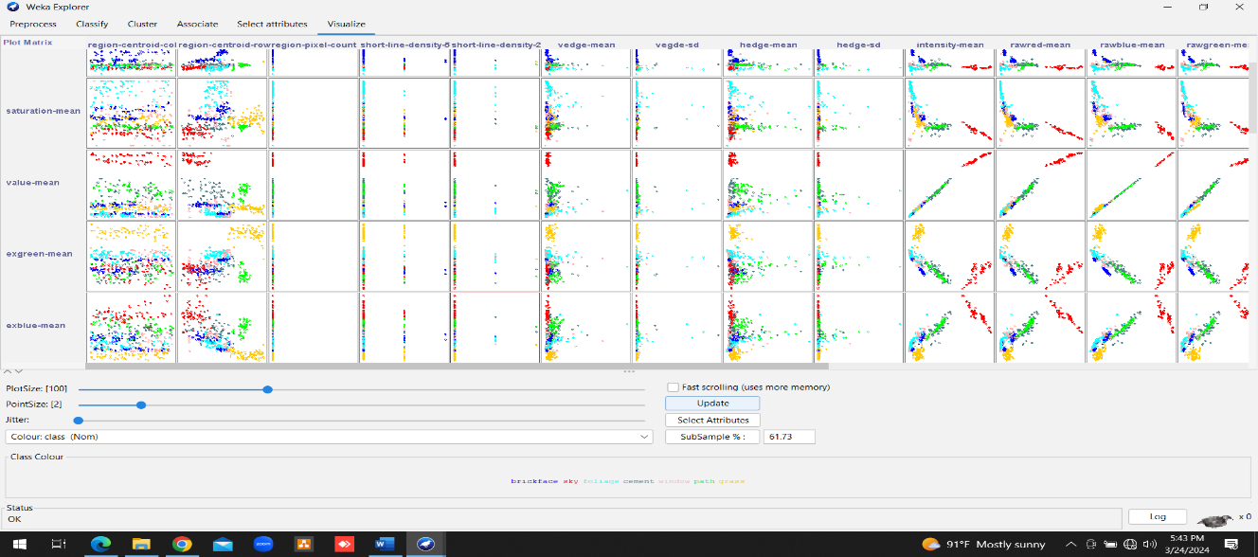

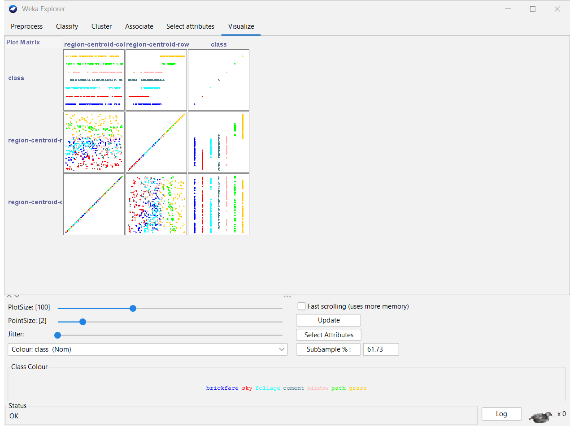

- Remove the attribute regional-pixel-count, short-line-density-2, short-line- density-5 in the source file and save the source file.

- Go to the attribute pane.
- Checking the regional-pixel-count attribute.
- Click on remove button.
- Likewise, check on short-line-density-2, short-line-density-5 attributes.
- Click on remove button.

Discussion
I learned the basics of Weka in today's practical lesson. My targets were to understand its interface, source file formats, and different types of data. By exploring the Weka interface with my own hands, I learned how to use it, understand how it works, and quickly change datasets. I also learned about the different file formats that Weka allows, which makes it easy to import and analyze data. I also learned more about the common types of data in Weka, which is important for jobs like preprocessing and modeling. It was very helpful for me to learn how to use Weka for data analysis and machine learning in this class.

